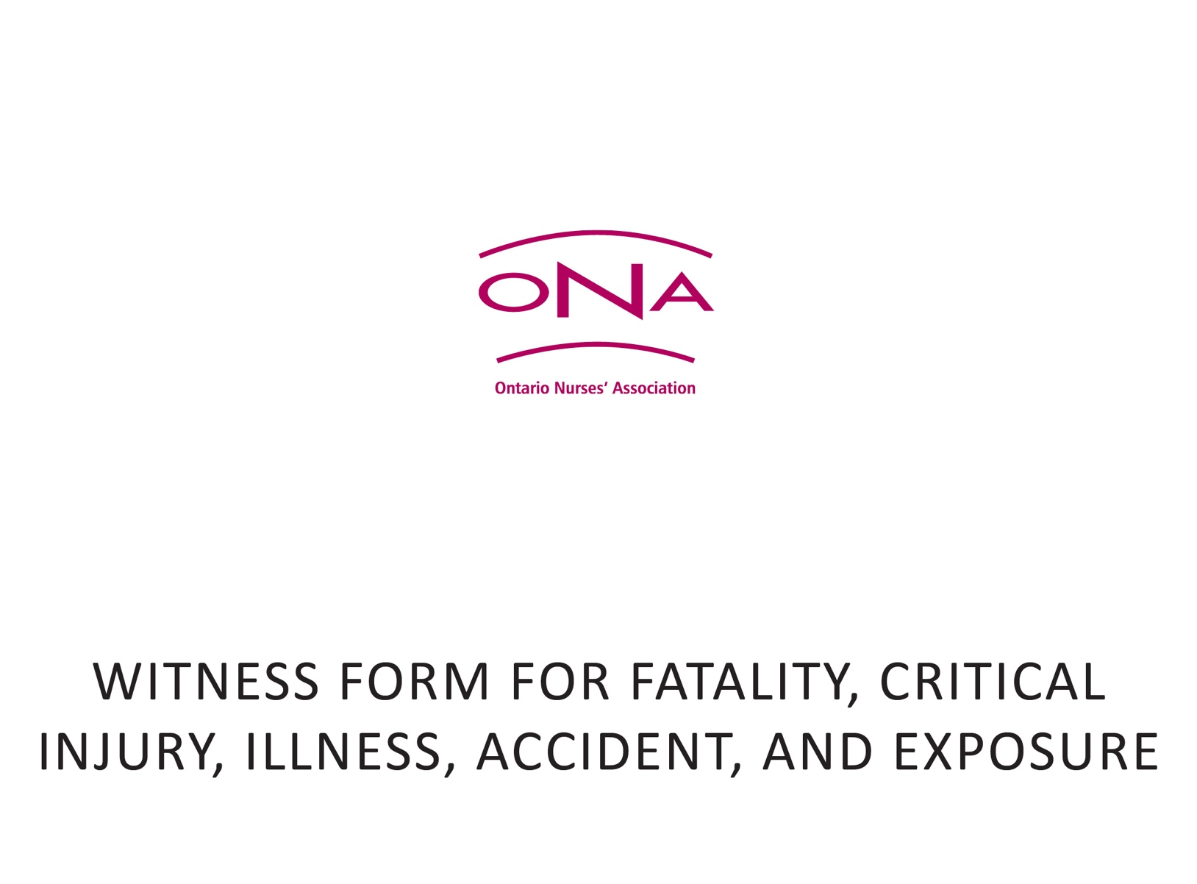

Please photocopy this form and use as many of the Witness Forms as necessary to fully record all details of each witness’s (e.g. injured worker, co-worker, supervisor, expert and any other relevant witness) responses as reported during the interview. Where multiple ONA Witness Forms are used, the witness should, after attesting that it is accurate, initial each page and sign and date the last page. Provide the witness with a photocopy of their statement, if requested.

Time of Interview: |  |  | Date of Interview:
Place of Interview:
Name of Witness:
Address of Witness:
Phone Number of Witness:
Email of Witness:
Name of Interviewer:
Witness Statement:
Is this an accurate account of what you just told me?
Witness Signature: |  |  |  | Date:
Interviewer Signature: |  |  |  | Date:

